**Chap 11: Simple Linear Regression**

**Purpose**

Comparison: ch9, ch10

Relationship: ch11

**Regression 🡪 Predict**

Example:

chiều cao 🡪 cân nặng

học vấn 🡪 thu nhập

chiều dài lá 🡪 diện tích lá

diện tích nhà 🡪 giá nhà

thu nhập 🡪 chi tiêu

**Regression analysis is used to:**

Predict the value of a dependent variable based on the value of at least one independent variable.

Explain the impact of changes in an independent variable on the dependent variable.

**Simple linear regression 🡪 Find a linear equation between 2 variables. (Independent variable X and dependent variable Y)**

Example: chiều cao 🡪 cân nặng X: chiều cao Y: cân nặng

học vấn 🡪 thu nhập X: học vấn Y: thu nhập

chiều dài lá 🡪 diện tích lá X: chiều dài lá Y: diện tích lá

diện tích nhà 🡪 giá nhà X: diện tích nhà Y: giá nhà

thu nhập 🡪 chi tiêu X: thu nhập Y: chi tiêu

1. **Simple Linear Regression model:**

**Dependent variable** (Y): the variable we **wish to predict or explain**.

**Independent variable** (X): the variable used **to predict or explain the dependent variable.**

Only one independent variable, X.

Relationship between X and Y is described by a linear function.

a linear function y = ax + b

Changes in Y are assumed to be related to changes in X.

1. **Equation of linear regression $\hat{y}={\hat{β}}_{0}+{\hat{β}}_{1}*x$**

$x$: independent variable value (giá trị của biến độc lập)

$\hat{y}$: predicted value (kết quả dự đoán)

${\hat{β}}_{0}$ (Point estimate for y-intercept - hệ số chặn/hệ số tự do)

${\hat{β}}_{1}$ (Point estimate for slope -hệ số góc)

${\hat{β}}_{1}<0 → X increase, Y decrease → negative relationship$ ${\hat{β}}_{1}=0 → X increase, Y unchange → no relationship$ ${\hat{β}}_{1}>0 → X increase, Y increase → positive relationship$

**Compute ${\hat{β}}_{1}$**

1st way hand calculates ${\hat{β}}_{1}=\frac{S_{xy}}{S_{xx}}=\frac{\sum{}(X-\underline{X})*(Y-\underline{Y})}{\sum{}{(X-\underline{X})}^{2}}$

$S_{xx}=\sum{}{\left(x_{i}-\underline{x}\right)}^{2}=\sum{}{x_{i}}^{2}-\frac{{\left(\sum{}x_{i}\right)}^{2}}{n}$

$S_{yy}=\sum{}{\left(y_{i}-\underline{y}\right)}^{2}=\sum{}{y_{i}}^{2}-\frac{{\left(\sum{}y_{i}\right)}^{2}}{n}$

$S_{xy}=\sum{}\left(x_{i}-\underline{x}\right)\left(y_{i}-\underline{y}\right)=\sum{}x_{i}y_{i}-\frac{\left(\sum{}x_{i}\right)\left(\sum{}y_{i}\right)}{n}$

2nd way CASIO

3rd Excel

**Compute ${\hat{β}}_{0}$**

1st way hand calculates ${\hat{β}}_{0}=\underline{y}-{\hat{β}}_{1}\underline{x}$

$\underline{y}=\frac{\sum{}y_{i}}{n}$

$\underline{x}=\frac{\sum{}x_{i}}{n}$

2nd way CASIO

3rd Excel

**Use linear regression to predict future values**

1. $|R|$, $R^{2}$ 🡪 **Strength of a linear relationship (Strong/Weak)** & $R$ 🡪 **Positive/Negative correlation**

**Sample correlation coefficient $R=\frac{S_{xy}}{\sqrt{S_{xx}S_{yy}}}$**

$-1 ≤ R ≤ 1$

$R<0 → X increase, Y decrease → negative correlation$ $R=0 → X increase, Y unchange → no correlation$ $R>0 → X increase, Y increase → positive correlation$

R and ${\hat{β}}_{1}$ have the same sign.

**Coefficient of determination (R Square) $R^{2}=\frac{{SS}_{R}}{{SS}_{T}}$**

Meaning: the portion (%) of the total variation in the dependent variable that is explained by variation in the independent variable.

$|R|$ and $R^{2}$ both measure the strength of a linear relationship.

$0 ≤ \left|R\right| ≤ 1$, $0 ≤{ R}^{2} ≤ 1$

${ R}^{2}$ ~ 0 → weak correlation ${ R}^{2}$ 
 ~ 1 → strong correlation

1. **Compute sums of squares**Diagram

   Description automatically generated with medium confidence

Total sum of squares: ${SS}_{T}=\sum{}{\left(y_{i}-\underline{y}\right)}^{2}=\sum{}{y_{i}}^{2}-\frac{{\left(\sum{}y_{i}\right)}^{2}}{n}$

Regression sums of squares: ${SS}_{R}=\sum{}{\left({\hat{y}}_{i}-\underline{y}\right)}^{2}={\hat{β}}_{1}S_{xy}$

Error sum of squares: ${SS}_{E}=\sum{}{\left(y_{i}-{\hat{y}}_{i}\right)}^{2}={SS}_{T}-{SS}_{R}$

SST = SSR + SSE

1. **Standard error of estimate $\hat{σ}=\sqrt{\frac{{SS}_{E}}{n-2}}$**
2. **Residual Analysis** 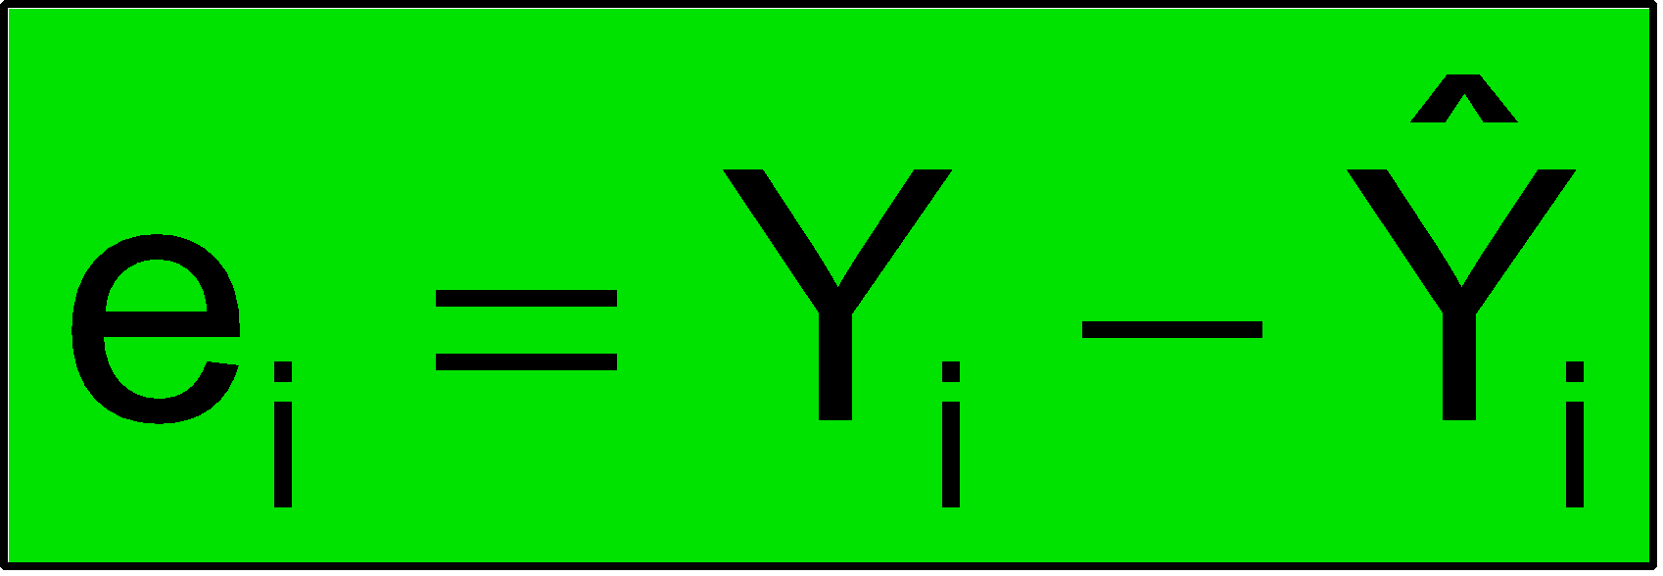

Meaning: is the difference between its observed and predicted value.

1. **Hypothesis Testing**

| **Test for the intercept** | **Test for the slope** | **Test for zero correlation** |
| --- | --- | --- |
| $H_{0}:β_{0}=0$ $H_{1}:β_{0} ≠ 0$ | $H_{0}:β_{1}=0$ (No linear relationship) $H_{1}:β_{1} ≠ 0$ (Linear relationship does exist) | $H_{0}:ρ=0$ (No correlation) $H_{1}:ρ ≠ 0$ (Correlation exists) |
| **Test statistic $t_{stat}=\frac{{\hat{β}}_{0}-β_{0}}{se({\hat{β}}_{0})}$ $se\left({\hat{β}}_{0}\right)=\sqrt{{\hat{σ}}^{2}(\frac{1}{n}+\frac{{\underline{x}}^{2}}{S_{xx}})}$** | **Test statistic $t_{stat}=\frac{{\hat{β}}_{1}-β_{1}}{se({\hat{β}}_{1})}$ $se\left({\hat{β}}_{1}\right)=\sqrt{\frac{{\hat{σ}}^{2}}{S_{xx}}}$** | **Test statistic** |
|  |  |  |
| If the test statistic is in region of rejection 🡪 **Reject $H_{0}$**  If the test statistic is in region of non-rejection 🡪 **Fail to Reject $H_{0}$** | | |

**t distribution**

**ch8, ch9: one-sample df=n-1**

**ch10: two-sample df=n1-1+n2-1=n1+n2-2**

**ch11: regression df=n-2**